Extra-Curricular Clubs

Dear Parent/Carer,

We are pleased to offer your child an opportunity to attend one of our extra-curricular clubs. These are designed to enhance your child’s learning, enjoyment and experience of their time at Pool Hayes Academy.

All extra-curricular clubs are scheduled in advance, with your child being informed of the days and time they are taking place. In the event that a club is cancelled, we would, of course, keep you updated via our normal academy communication pathways.

If you would like your child to benefit from this fantastic opportunity and they would like to attend one of our extra-curricular clubs, please complete the slip and return to the academy as soon as possible so we are aware that you have given them permission to stay.

Most of the clubs will last one hour from the end of the normal academy day, but please check the finish times with the relevant teacher as these may change depending upon the activity. Please note that some of the clubs have limited spaces available. In this instance, places will be reserved on a first come, first served basis. It will be your responsibility to ensure your child returns home safely after their extra-curricular club has ended. Students may be withdrawn from extra-curricular clubs if their behaviour is deemed inappropriate.
If you have any questions, please do contact me at cassie.pearson@attrust.org.uk

Yours sincerely,
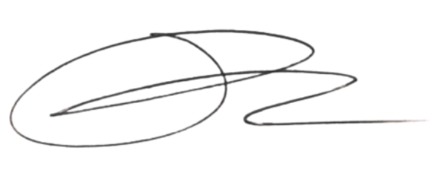

Mrs Cassie Pearson
Associate Assistant Principal

___________________________________________________________________________

I give my permission for my son/daughter:
Name:___________________________________________________ Form:_____________
To participate in the following extra-curricular club: ________________________________
Day: ____________________________ Times:___________________________________
I understand it is my responsibility to ensure my child returns home safely, after the extra-curricular club has ended.
Signed_____________________________________________________________________

Please return this consent form to school as soon as possible

