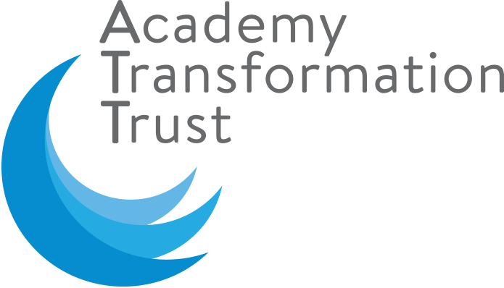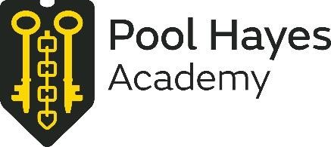

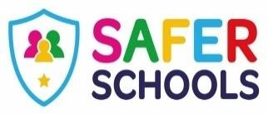

Dear Parent/Carer

We wanted you all to know that we are really looking forward to meeting your child. We know that it's really hard to cope with everything that is going on at the moment with everyone juggling their normal daily jobs with supporting their children and caring for loved ones.

An inevitable consequence of the recent government lock down is that children nationally are getting more screen time than usual, and this can lead to children taking increased risks online. The risks are so wide and varied that it takes a whole team of people just to stay on top of them and we fully understand that you as parents can't possibly do that alone. Fear not, we are here to help.

We have taken the exciting decision to launch a Trust-wide safer schools app designed by a team of experts to ensure that parents have the information that they need to hand to protect their children from online risks. Research has shown that parents and carers are by far the most effective protective factor to reduce the online risks to children. The app was designed by Jim Gamble (former CEO of CEOP - the government Child Exploitation and Online Protection Command) and has a team of people monitoring the apps, websites and platforms that children access to identify risks (and protective factors) to ensure that your Safer Schools app is always up to date.

Think of the app as a directory of helpful information about various popular apps and platforms and games that your child wants to/is accessing. You can scroll through the information to see what you didn’t know about the app/platform etc. or you can search for the app on Safer Schools and relevant information will appear to help you decide how you feel about that app/platform. The information appears as short one-minute videos or as a short summary. You will also see links to more information should you want a greater depth understanding of something in particular.

You will receive little notifications from the app that update you as a new function or feature comes out on widely used platforms so that you can trust the app to tell you the truth about what is happening or could happen in your child's online world.

If your child experiences **online bullying, sadfishing, or even receives or sends an explicit image online** the app will signpost you to support and guidance as to what you can do to do next. During school hours though, we would encourage you to seek the support of the academy by disclosing the information to us directly on **safeguarding@poolhayes.attrust.org.uk** and we will help as far as we possibly can. There is also a directory for the contact details for every local authority to ensure that you can easily make direct referrals, if you needed.

Your child will be sent their own version of this app. The child version will help children to understand the risks in their online environment and self-mitigate. It also provides an authentic source of advice for any problems that your child is anxious about that you don’t yet know about and hopefully prevents them from needing to search for information and perhaps finding some advice that is less authentic.

One of the key messages that we have been led to understand in the past is that *' you must not send an image of yourself because once an image is out there, it's forever'*. This can lead to young people believing that they can't seek help or can't recover from mistakes that are made online. But the reality is that if young people seek help as soon as they realise their mistake, a huge amount of mitigation can be done to reduce the impact of any image shared with or without permission. Young people blame themselves for letting adults down, so they don’t always tell us, instead they try to cope with the situation themselves. A no blame culture and good signposts for support to get pictures taken down or blurred out can really make a huge difference to a child's mental health and wellbeing.

Your version of the app is slightly different to your child's version though they will look the same. The updates and information that you get will, for example, tell you about the online challenges going around, what they look like and what to look out for, whereas your child's version of the app will just remind them to look at the generic online challenges section in the app and to remember to tell and adult if they are sent one. This is to ensure that we don’t promote anything unintentionally that a child isn't already aware of and accidently increase the reach of that particular risk.

There are loads of fun features in this app too - you can do quizzes on different topics for fun and even compete against your child or other adults in the family.

We can also use this app to communicate with parents and pupils when it's difficult to communicate in other ways, so please do take the 60 seconds it takes to download this app.

For those of you getting involved with home schooling - they even make resources and lesson plans for you (free). Just follow the simple steps below:

* Open a web browser on your desktop computer or laptop e.g. Chrome, Safari etc.
* Type into the web address [www.oursaferschools.co.uk/home-learning-hub](http://www.oursaferschools.co.uk/home-learning-hub) and hit return and this will take your to our home page.
* Don’t forget to Like us and follow us @OurSaferSchools on Facebook and Twitter for more relevant information!

The best bit? It's free to you. I really hope that you can see how valuable a tool this app is and enjoy using it; it is a game-changer for keeping children safe online. So please don’t waste this opportunity and download the app as soon as you can!

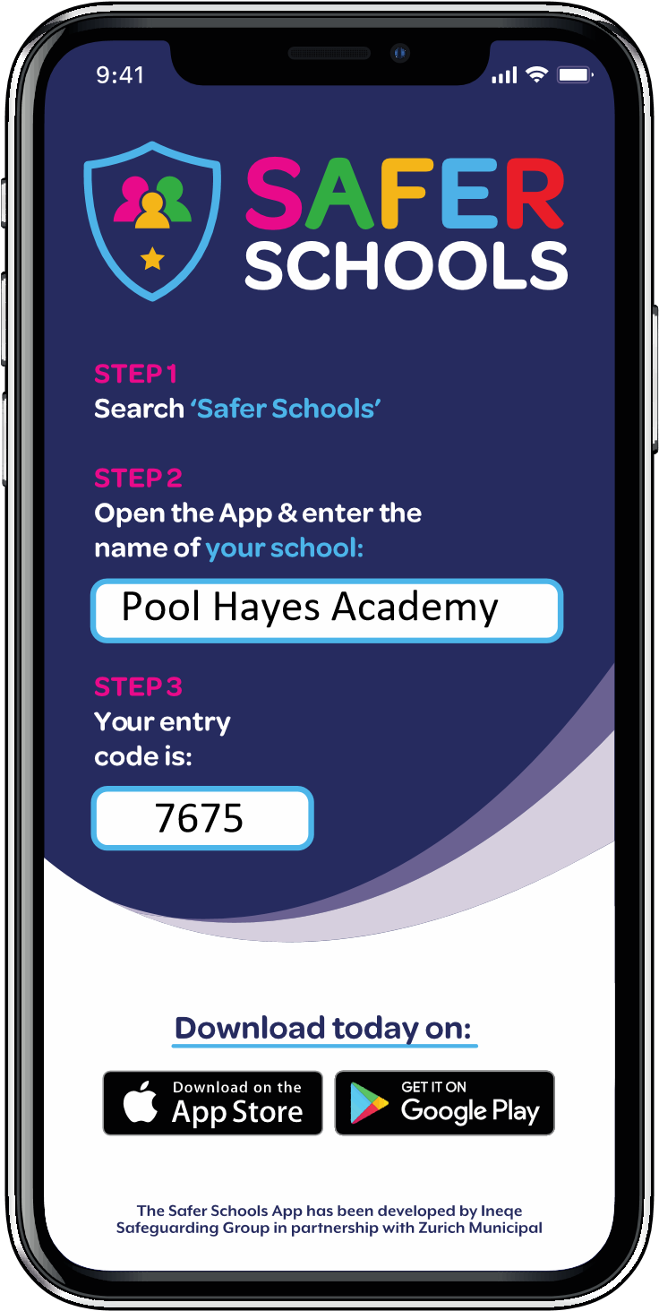

**Downloading the App - it's easy!**

* + Go to the app store
  + Search for 'Safer Schools' (look for the shield logo)
  + Download the app