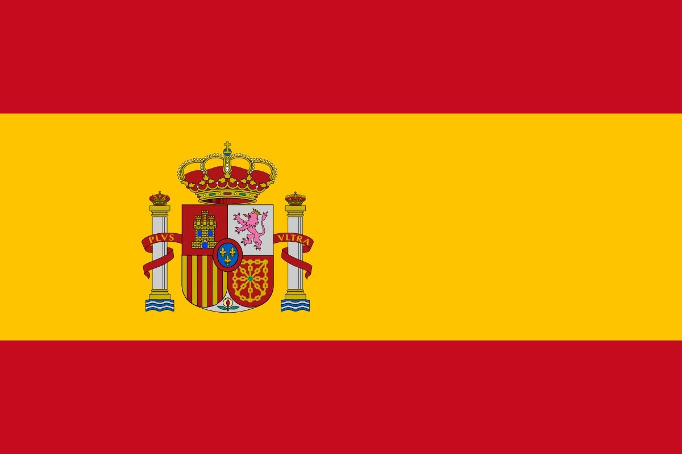

Year 6 Transition Spanish Challenge

Read the following interesting facts about the Spanish language. Your challenge is to create your own fact sheet or poster on the country of Spain.

Things to consider:

- Food (La comida)
- Festivals (Las fiestas)
- Culture (La cultura)
- Music (La música)
- Famous Spanish People. (Las personas famosas)
- Spanish Monuments (Los monumentos)
- Anything else of interest! (Algo más)

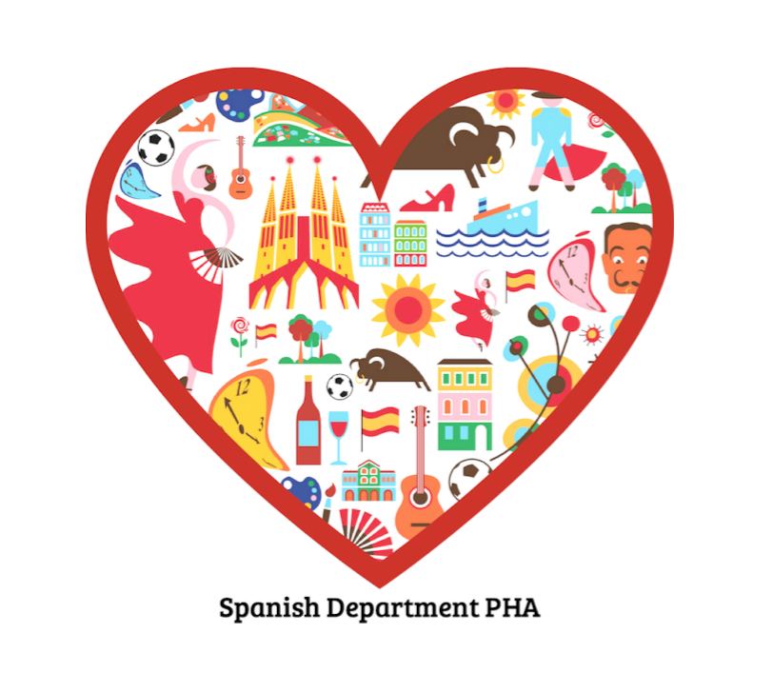
You can also look up extra information on the internet.

