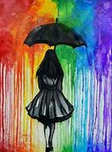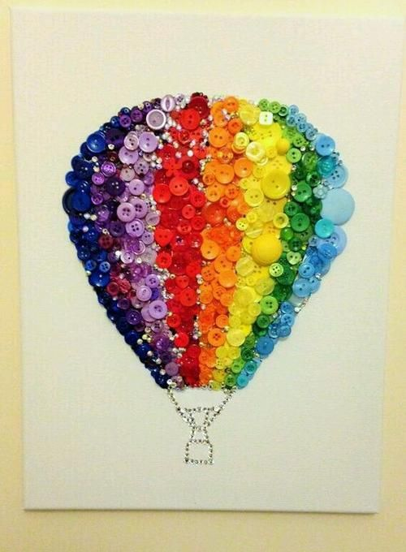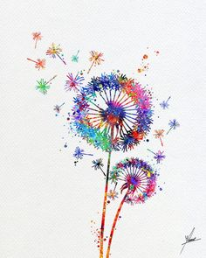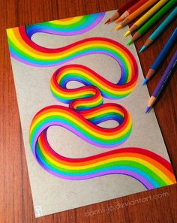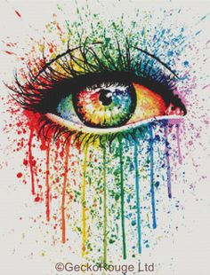

Art Competition

‘Rainbows’

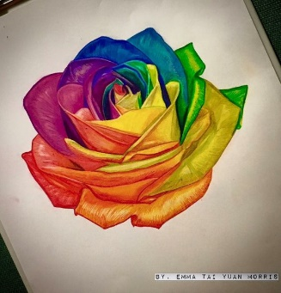

Scientifically, rainbows are a natural phenomenon that occur after rainstorms, they are caused by reflecting light against water. But spiritually, symbolically and emotionally they take on an entirely different meaning.

Rainbows can be said to represent rebirth, hope and growth that comes from challenge and adversity.

More recently, this can also be seen in the practice by children of creating rainbows to put in their windows to give people hope and to make people feel positive during these challenging times due to the Coronavirus.

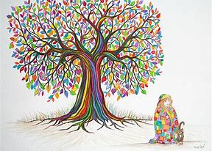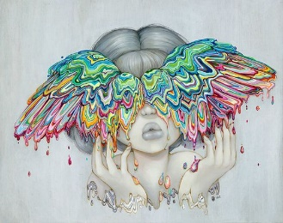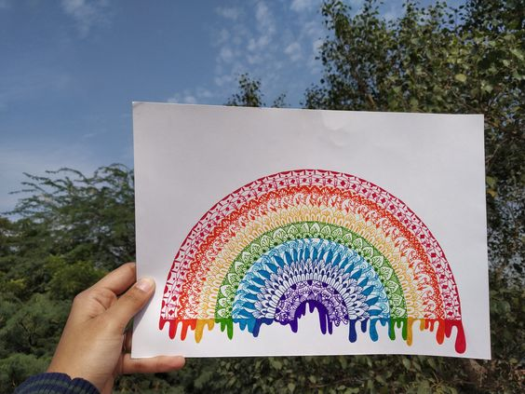

Rainbows are a strong visual image

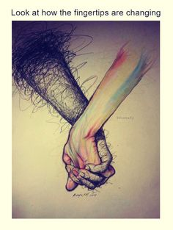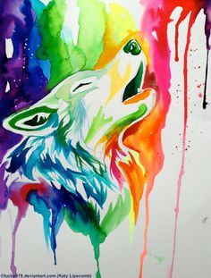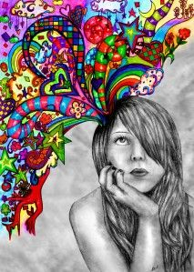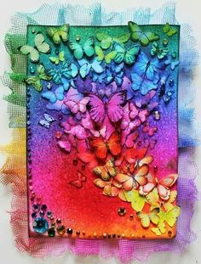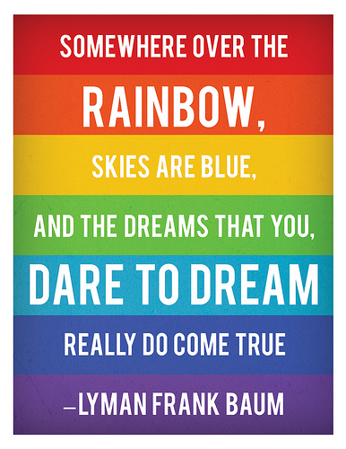

* Create a piece of artwork that represents ‘Rainbows’. It can represent what rainbows mean to you, to other people or you can think carefully about rainbows from a visual and symbolic point of view.
* The artwork can be created in any medium and any size, Be Creative, Just go for it!
* Please submit scanned or photographed entries via school email (a.kew@poolhayes.attrust.org.uk).