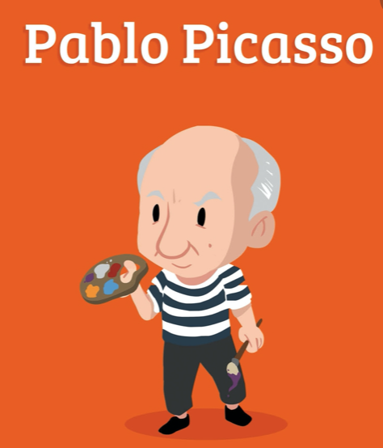
Why not try these activities at home? Students need to send a photo of the activity to c.donaldson@poolhayes.attrust.org.uk to show evidence that the task is complete. Students can colour the box when it is done. The pupil who has done the most activities by Monday 4th May will win a prize! Good luck y buena suerte!
Make MAGDALENAS (Fairy cakes) | Write a DIARIO  en espaňol | Draw a painting like PICASSO | Eat some chorizo | Watch una PELÍCULA with Spanish subtitles y COME PALOMITAS | Learn some flamenco steps  LINK | Sing / listen to una  CANCIÓN en español - find a youtube song | Do a virtual tour of the Prado Museum  LINK TO MUSEUM
Write a poem in Spanish | Make some paella  LINK for ideas.  Many versions available on YouTube. | Label the furniture of your house with post it notes in Spanish | Do a virtual tour of Madrid  LINK | Do some research about Machu Picchu in Peru. Create a leaflet or poster. | Speak Spanish in front of the mirror for 5 minutes everyday | Draw the Sagrada Familia. | Visit the Nou Camp Barcelona football stadium online  LINK
Play a game of UNO | Do some ZUMBA in Spanish  CACHUMBALERA ZUMBA | Watch a Spanish series in Netflix with English subtitles and do a summary in Spanish | Play SPANISH LOTERIA with your friends via Skype. Each person draws a grid 3x3 and the speaker says numbers 1-30. Winner for each line and then BINGO! | Reto Español - Find a Spanish word starting with the letter A for each category  LINK | Learn 5 new Spanish words and stick them in the fridge with post it notes. Read them every time you open the fridge using your Spanish phonics to perfect your accent. | Watch Spanish cartoons DIBUJOS ANIMADOS  LINK POCOYO | Text / Email your friends in Spanish
Teach your parents or siblings a new Spanish word / numbers etc. every day or a week. Be the teacher for 5 minutes a day 😊  LINK | Read this blog about Mexico  LINK MEXICO | Watch this video on how to prepare MEXICAN TACOS  LINK TACOS | Look for a Spanish menu in a restaurant in Spain. | Visit the IGUAZU FALLS in Argentina  LINK CATARATAS | Draw a plan of your house and label in Spanish | Film a video about yourself in Spanish. Minimum 5 sentences. Try to add different tenses! Parental consent required. | Read these reviews about a restaurant from Madrid  RESTAURANTE MADRID

* Parental consent and support required for these tasks.

