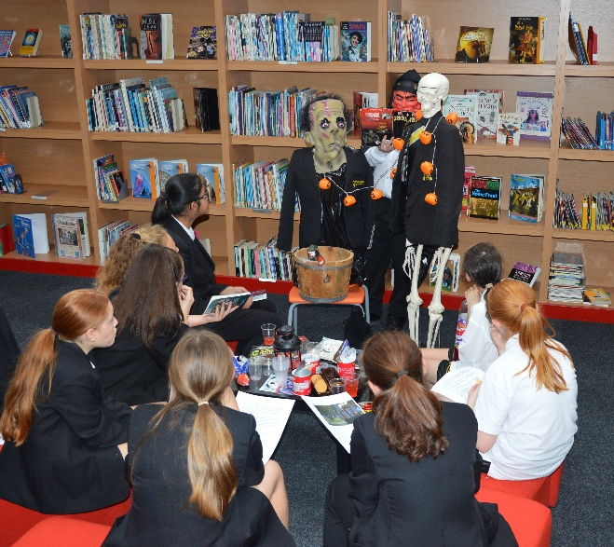
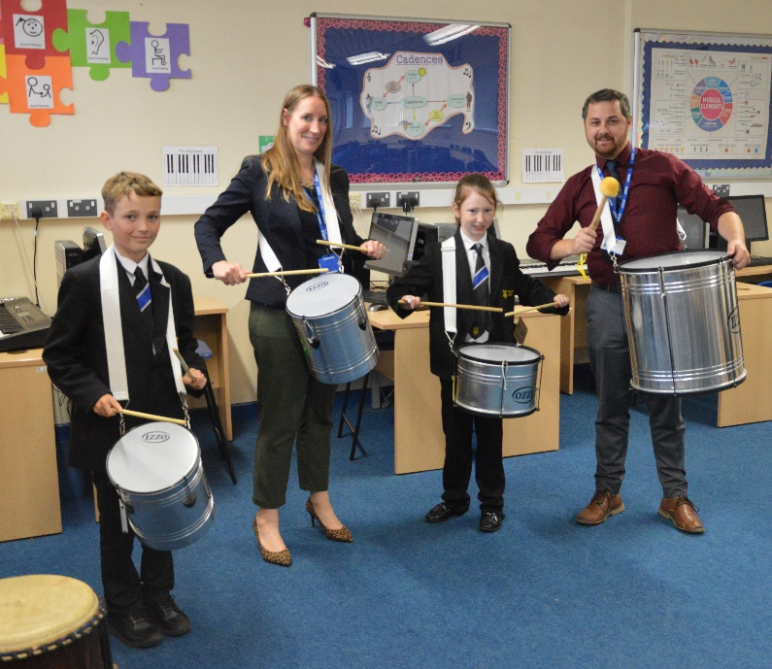
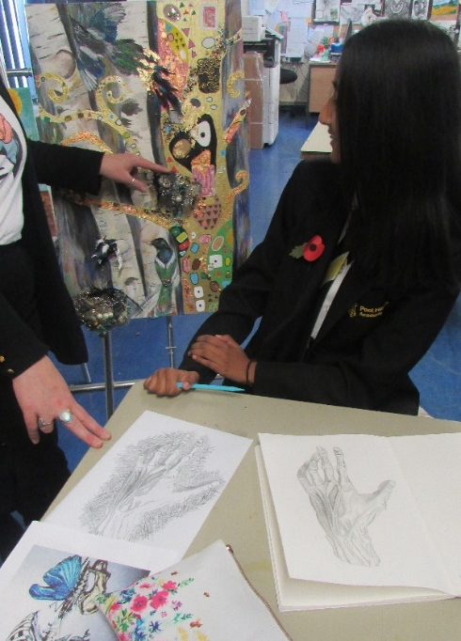
Pool Hayes Academy

Enrichment

LUNCH TIME
Monday | Get up and Drum | All Welcome | 51 | WD
 | Futsal | KS4 | Sports Hall | RF
 | Table Tennis | KS3 | Fitness Suite | LJF
 | Basketball | All | Gym | JE
 | Dance | Year 7 | Dance Studio | GLC
 | Drama | Year 7 | 31 | TJM and JXR
Tuesday | Futsal | KS3 | Sports Hall | LJF
 | Basketball | All | Gym | LCJ
 | Table Tennis | KS4 | Fitness Suite | AS
 | Guitar/Keyboard Club | All | 51 | WD
 | Dance | Year 9 | Dance Studio | GLC
Wednesday | Badminton | All | Sports Hall | LJF
 | Basketball | All | Gym | JXA
 | Table Tennis | KS3 | Fitness Suite | RJF
 | Music | GCSE | 51 | WD
Thursday | Badminton | All | Sports Hall | RF
 | Table Tennis | KS4 | Fitness Suite | LCJ
 | Basketball | All | Gym | AS
 | Dance | Year 9 | Dance Studio | GLC
 | Music | GCSE | 51 | WD
Friday | Dance (drop in) | GCSE/BTEC | Dance Studio | GLC
 | Chess Club | All Welcome | 7 | NP
 | Music | GCSE | 51 | WD

AFTER SCHOOL
Monday | Dance Intervention | GCSE | Dance Studio/Main Hall | AW
Tuesday | Netball | All Welcome | PE Dept | LCJ/JXA/AS
 | Rugby | All Welcome | PE Dept | LJF and RF
 | Art Club | All Welcome | 35 | LLR
 | Art Access/Intervention | KS4/KS5 | 35 | LLR
 | D & D | All Welcome | Library | AP/Pupil Led
 | Spanish Intervention | KS5 | 18A/18B | MV
 | Performance Club | All Welcome | Dance Studio | GLC
 | Dance Choreography | GCSE | Dance Studio | GLC
Wednesday | Netball Fixtures | All Teams | PE Dept | LCJ and JXA
 | Basketball | All Welcome | PE Dept | LJF and RF
 | GCSE Art | KS4 | 34 | AXK
 | GCSE Creative Tech | KS4 | D7 | MA
 | GCSE Music | KS4 | 51 | WD
 | GCSE Ethics | KS4 | R1 | FA
 | Eco Club | All Welcome | Garden/20B | HJC/JXB
 | D&T Woodwork | Year 7 | D4 | TAB and CBB
 | Computing for girls | Year 8 | 44 | MGS
 | Coding Club | Year 10 | 44 | MGS
 | Computer Modelling | KS4 | D1 | CBB
 | Spanish Intervention | KS5 | 18A/18B | MV
 | Science Club (Week A) | Year 7/8 | C1 | NDC
 | Dance Choreography | GCSE | Dance Studio | GLC
Thursday | Basketball | KS4 | Gym | PE Staff
 | Fitness | Year 9+ | Gym | JXA
 | Book Club | Year 7/8 | Library | AP/Pupil Led
 | Dance Show Rehearsal | Dancers | Dance Studio | GLC
 | Dance Choreography | GCSE | Dance Studio | GLC
Friday | Art Intervention | GCSE | 33/34 | GFD/AXK
 | Rugby | All Welcome | PE Dept | RF
 | Drama Intervention | GCSE | Drama Studio | TJM/JXR
 | Dance Rehearsals | GCSE/BTEC | Dance Studio | GLC

